## 结果截图

中文输出出现了乱码，但是成功写入到了scoreAnalysis文件中，总分计算正确。

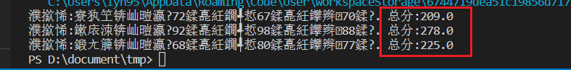

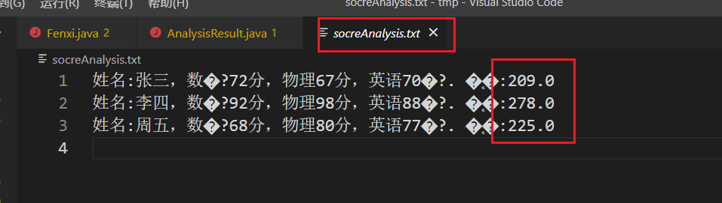

## 代码截图

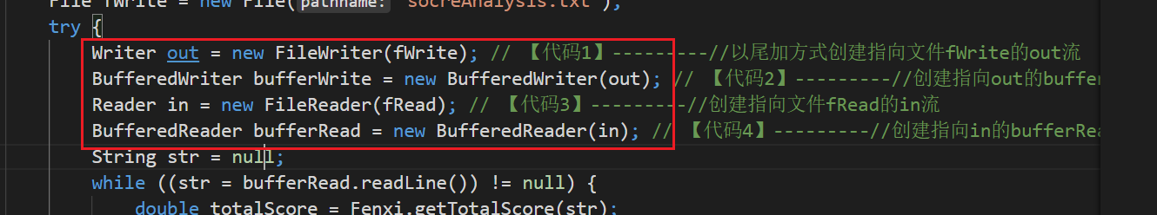

## 源码

package chapter10_1;

import java.io.*;

import java.util.*;

public class AnalysisResult {

public static void main(String args[]) {

File fRead = new File("score.txt");

File fWrite = new File("socreAnalysis.txt");

try {

Writer out = new FileWriter(fWrite); // 【代码1】---------//以尾加方式创建指向文件fWrite的out流

BufferedWriter bufferWrite = new BufferedWriter(out); // 【代码2】---------//创建指向out的bufferWrite流

Reader in = new FileReader(fRead); // 【代码3】---------//创建指向文件fRead的in流

BufferedReader bufferRead = new BufferedReader(in); // 【代码4】---------//创建指向in的bufferRead流

String str = null;

while ((str = bufferRead.readLine()) != null) {

double totalScore = Fenxi.getTotalScore(str);

str = str + " 总分:" + totalScore;

System.out.println(str);

bufferWrite.write(str);

bufferWrite.newLine();

}

bufferRead.close();

bufferWrite.close();

} catch (IOException e) {

System.out.println(e.toString());

}

}

}

//

package chapter10_1;

import java.util.*;

public class Fenxi {

public static double getTotalScore(String s) {

Scanner scanner = new Scanner(s);

scanner.useDelimiter("[^0123456789.]+");

double totalScore=0;

while(scanner.hasNext()){

try{ double score = scanner.nextDouble();

totalScore = totalScore+score;

}

catch(InputMismatchException exp){

String t = scanner.next();

}

}

return totalScore;

}

}